National Seismic Network System of Turkey

Turkish Republic, Ministry of Public Works and Settlement, General Directorate of Disaster Affairs, Earthquake Research Department, Eskisehir Yolu 10.km, 06530, Lodumlu, Ankara, TÜRKİYE

Introduction
In order to mitigate disaster losses, it is necessary to establish an effective disaster management and risk system. The first step of the management is constituted by preparedness studies before the earthquake (disaster). In order to determine disaster and risk information it is necessary to have a seismological observation network.

In order to monitor, record, evaluate and archive earthquakes in the country-wide scale and after a probably destructive earthquake inform the public authority immediately, a project named “Development of the National Seismic Network Project” has been started. 6 Three Component Short Period, 63 Broad-band, 13 One Component Short Period stations, 65 Local Network- Broad-band (Fig. 1) and 247 accelerometers have been operated in the frame of this project (in the IRIS Network list: Permanent network code : TU, Network : National Seismic Network of Turkey (DDA)). All of the stations transmit continuously their signal to the ERD (Earthquake Research Department) seismic data center in Ankara. Capability of the network is to determine an earthquake which is minimum local magnitude ML= 2.8 generally, in some region local magnitude threshold is ML=1.5.

Earthquake activity in Turkey and surrounding region has been observed 7 days / 24 hours, in ERD data center in Ankara. After the manual location of an earthquake, If the earthquake magnitude is over 4.0, system sends to SMS (message) automatically to the authorized people deal with it (such as public and national local crisis center) and Inform immediately scientific institutions, press, public and national-local crisis center by fax and e-mail (Fig. 2). Data exchange has been carried out EMSC-CSEM.

National Seismological Observation Network of Turkey
Investigate the causes of earthquake and determine reliable earthquake parameters by tracing active faults perform studies on earthquake hazard and risk analysis, determine the reoccurrence period of the earthquake prediction research are the purposes of the project. 147 seismic stations have been operated in the frame of this project (detail info: http://sismo.deprem.gov.tr Fig.1).
Observation studies along North Anatolian Fault System have been carried out since 1990 by continuous and online data acquisition. Especially since 2000, earthquakes occurred in the country have been observed continuously on real-time basis (Fig.3). A high quality data has been provided by broad band stations of GDDA (General Directorate of Disaster Affairs)-ERD. Data presentation and revision of data base studies were completed in December 2008.

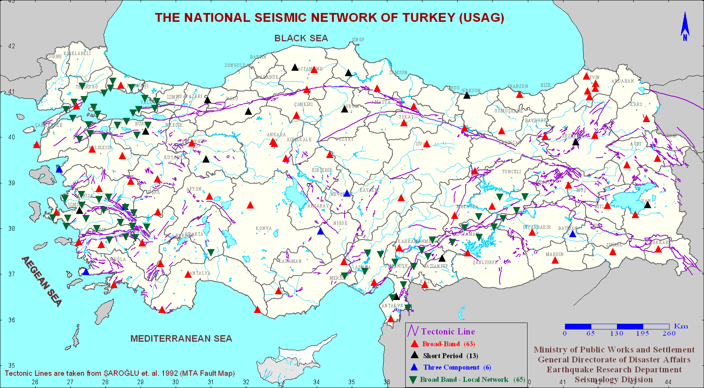
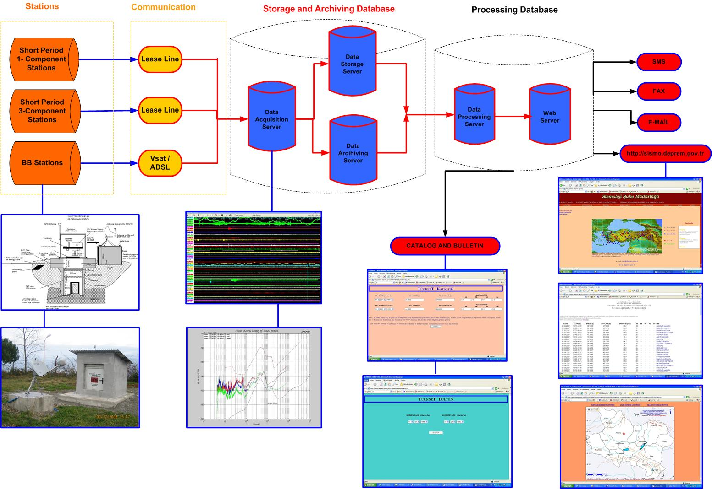
Fig.1. Stations of the National Seismological Observation Network of Turkey (Jan. 2009).

Fig. 2. Data processing system of the Network.

Specification of the Sytem :
The data is provided by Scream or Earthworm in real-time.
Data format (SUD, SAC, (mini) SEED)
Request methods (FTP)
Continuous data, Data acquisition format GCF
Archiving (Scream and Earthworm for waveform data)
MSSQL for bulletin and catalog

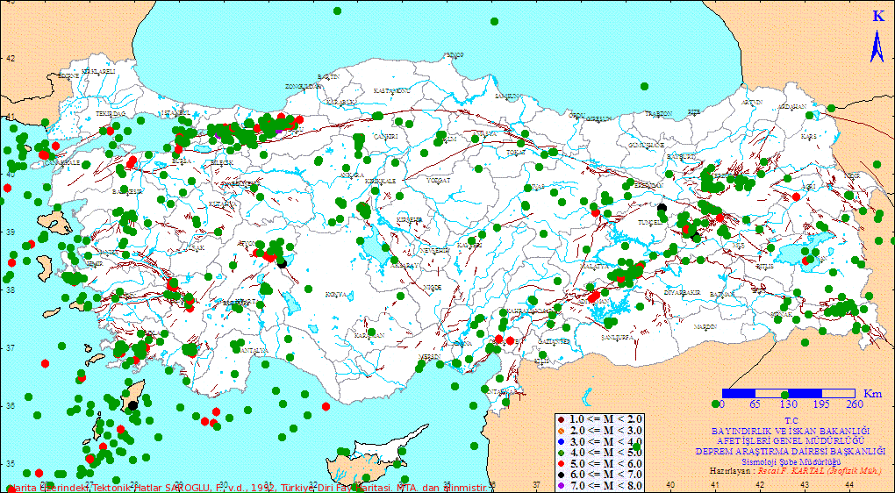
Fig. 3. Earthquake distributions of Turkey (1999 – 2008, M =>4.0) recorded by the Network.

Strong Motion Network of Turkey
The main purposes for the operating strong ground motion network are;
-to measure the acceleration and forces that cause damage to the buildings
-to develop the methods of constructing earthquake resistant structures,
-to collect the data intended for the preparation of the micro zoning map and the constitution of the data base also for the studies of the earthquake hazard and risk, earthquake master plans and earthquake scenario of the provinces.
At present, 247 accelerometers have been operated in National Strong Ground Motion (Accelerometric) Network (http://angora.deprem.gov.tr ) (Fig. 4). It is necessary to increase the number of accelerometers at least 1000. This network has been operated only by our Ministry in the county-wide scale.

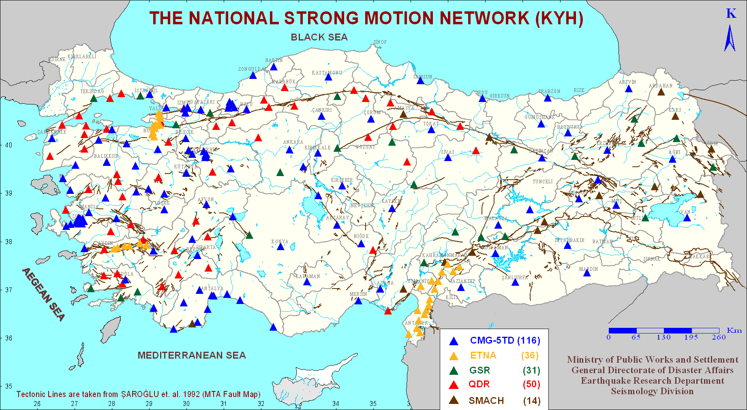
Fig. 4. Stations of the National Strong Ground Motion Network (Jan. 2009)

Operation of the Local Strong Motion Networks
Under the frame of the “the Development of the National Strong Motion Recording System and the Establishment of the Dense Local Networks” project; BYTNet (Bursa-Yalova 14 instruments), DATNet (Aydın-Denizli 6 instruments), MATNet (K.Maraş-Antakya 18 instruments), ANTNet (Antalya 10 instruments), DNet (Düzce 5 instruments) and ANANet (Eskişehir 4 instruments) local networks have been established (Fig. 5).
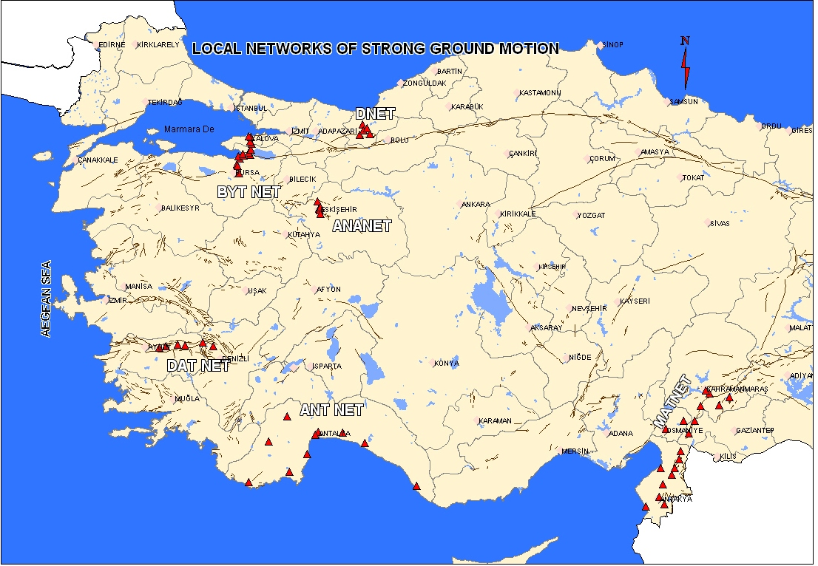
Fig. 5. Local Strong Ground Motion Networks

TURDEP (Multi - Disciplinary Earthquake Researches in High Risk Regions of Turkey Representing Different Tectonic Regimes ) Project
For earthquake hazard reduction, it is aimed to observe earthquake activity and earthquake precursors by multidisciplinary studies related to the three main fault zones in our country and to introduce the earthquake hazard seriously in the regions under risk (Fig. 6). Thus, a data base information will be obtained for a disaster management system in the international standards. 14 universities participate in this project which is supported by TÜBİTAK- Marmara Research Center (http://www.mam.gov.tr/eng/institutes/ydbe/ydbe-projeler/turdep2009.html ).

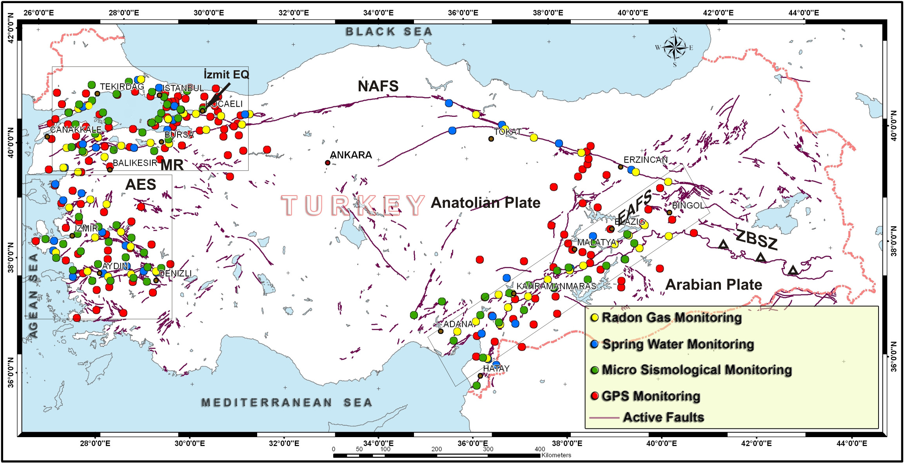
Fig. 6. Locations of the established and continuously run monitoring stations under the scope of the project. Abbreviations are MR, Marmara region; AEP, Aegean Extensional Province; EAFS, East Anatolian Fault System; NAFS, North Anatolian Fault System; ZBSZ, Zagros-Bitlis suture zone. Arrowhead points to the epicenter of the İzmit earthquake of 17 August 1999.
Benefits of the Project
-Investigate the causes of earthquakes
-Determine the origin time, magnitude, location and depth of earthquakes
-Observe all active faults
-Study on earthquake hazard and risk analysis
-Determine the reoccurrence period of the earthquakes
-Study on the earthquake prediction research
-Prepare hazard maps and to direct Emergent Aid System
-Prepare bulletins, earthquake catalogs and archive data
-Constitute data base for the earthquake information system
-Inform immediately scientific institutions, press, public and national-local crisis center
-Improve earthquake resistant building techniques,
-Provide the utilization of the network as Early Warning System at the places which have strategically importance.

